Student Handout 3

Lesson 3 – Oil and Natural Gas: Deposits
Activity 1 – Demonstrating Porosity in Rocks

Introduction
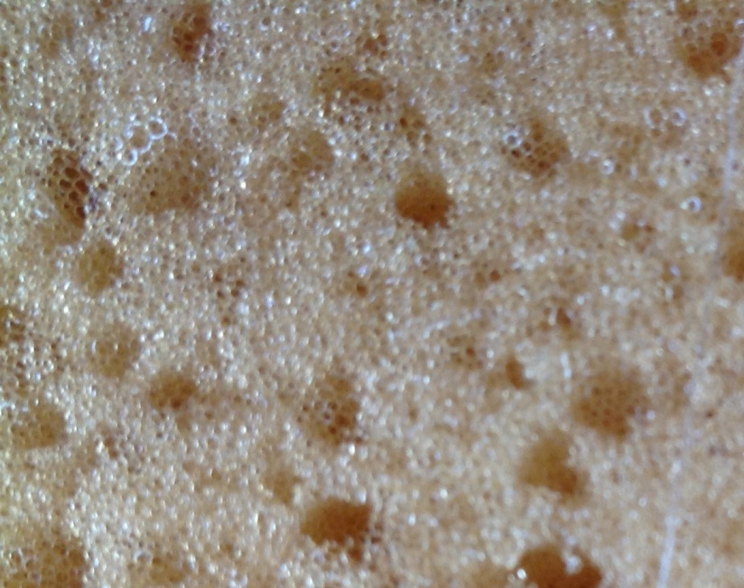
Oil and natural gas deposits occur in the sedimentary rocks in the Earth’s crust. How is it possible for a liquid or gas to be “in” a rock? The answer lies in the picture on the right. This is a close up picture of a sponge. Notice that the sponge has a lot of holes in it—these are called “pores”. Some of the rocks in the Earth’s crust also contain pores. Sometimes the pores can be easily seen, but usually they are tiny and can only be seen with a microscope. Oil and natural gas can be stored in these pores.

Materials
- 1 sample each of sandstone, shale, limestone, and chert
- Magnifying glass
- Eye dropper
- Water

Procedure
- Write a brief description of each rock, use the magnifying glass to help you notice small details.
- With your fingers observe the surface texture of each rock and record in the results section what you determined.
- Now use the eye dropper to place a drop of water on each of the rock samples.
- Describe for each rock if the water sits on the surface of the rock or soaks into the rock.
Results

Rock | Description
Sandstone
Shale
Limestone
Chert

Rock | Surface Texture |  | Behavior of Water Drop
 | Rough | Smooth | Sits on Top | Soaks In
Sandstone
Shale
Limestone
Chert

Analysis and Conclusions
- Which rocks “allowed” the water to soak into them? Why?

- What was the relationship between surface texture of the rock and the behavior of the drop of water? Why?

- Which rocks would be good oil and gas reservoirs? Why?

