Student Handout 2

Lesson 2 – Oil and Natural Gas: Sedimentary Rocks
Lab 2 – Making Sedimentary Rocks
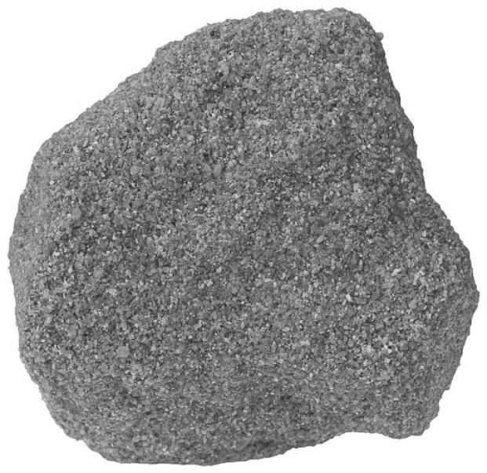
Introduction
In the previous lab you demonstrated the concept of deposition. In this lab you will simulate the final process in the formation of a sedimentary rock—cementation. The rock pictured on the right is called sandstone. Is this an apt name for this rock? Why? How do you think the particles came to be “stuck” together?

Materials
- Wax paper
- Magnifying glass
- Water
- Sugar
- Sand
- Spoon
- 2 Paper cups

Procedure
- Pour a spoonful of sand into a paper cup.
- Fill another cup with a teaspoon of water. Stir in 5 spoonfuls of sugar until it is dissolved.
- Pour the sugar water mixture slowly into the cup of sand until it is moistened. Pour off any excess water.
- Let the “rock” dry then carefully tear the paper cup off over a piece of wax paper.
- Let the “rock” sit and harden for at least 2 days.
- Use a magnifying glass to observe your “rock.” Draw an illustration of what you see.

Results
In the circle below make a close-up drawing of your rock and label it. Note in your drawing the sand grains and the cement that is holding the grain together.

Analysis and Conclusions
- What is the “cement” that is holding the grains of sand together in your rock?

- What happened to the water that was in the cup?

- Explain the process that turned the loose sand into a rock called sandstone.

