Student Handout 1

Lesson 2 – Oil and Natural Gas: Sedimentary Rocks
Lab 1 – Sedimentation

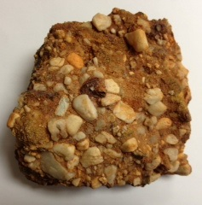
Introduction
Now that you have been introduced to the concept of sedimentary rocks and how they form, you will observe the process of deposition. Deposition is the settling to the bottom of sediments in a fluid. Deposition is a crucial step in the formation of sedimentary rocks. Look at the picture of the rock on the right. This is a rock geologists’ call “conglomerate.” How do you think it formed?

Materials
- Glass jar with lid
- Gravel
- Play sand
- Water
Procedure
- Fill the glass jar 1/3 full with a mixture of sand and gravel.
- Add water until the jar is about half full.
- Put the lid tightly on the jar.
- Make a hypothesis for this question: What will happen to the contents of the jar if it is shaken, then allowed to sit for 5 minutes?

Hypothesis:

- Shake the jar for 30 seconds.
- Set the jar on your desk in front of you and observe what is happening to the sand and gravel.
- Let the jar sit still for 5 minutes.
- Make a drawing of the jar and its contents in the results section.

Results
Make a drawing of your jar and label it.

Analysis and Conclusions
- Was your hypothesis proved or disproved? Explain your answer.

- What force causes the sediments to settle to the bottom of the jar?

- Which of the layers in your jar looks most like the picture of the rock on the front of the lab handout?

- How many layers of material formed in the jar?

- Describe the differences between each layer.

- Explain why the materials in the jar formed layers in the order that they did.

- Why is the water cloudy after you shake it?

- Do you think the water will become clear over time? Why?

