**Student Handout 2**

**Finding Gas**

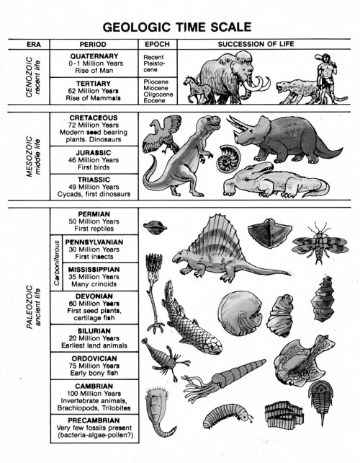

http://www.answersingenesis.org/articles/ee2/geologic-column