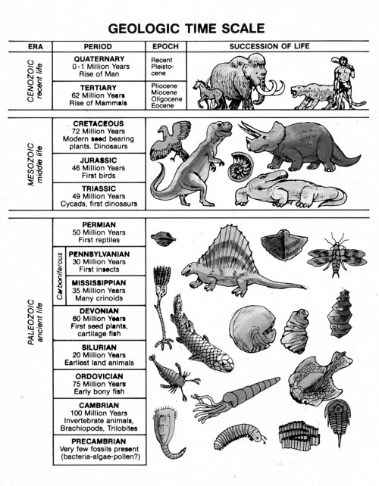

http://www.answersingenesis.org/articles/ee2/geologic-column



http://www.answersingenesis.org/articles/ee2/geologic-column