Student Handout 4
Name ____________________
Date _____________________
Class _____________________

Lesson 3—Oil and Natural Gas Exploration and Production
Lab 3—Investigating Porosity

Introduction
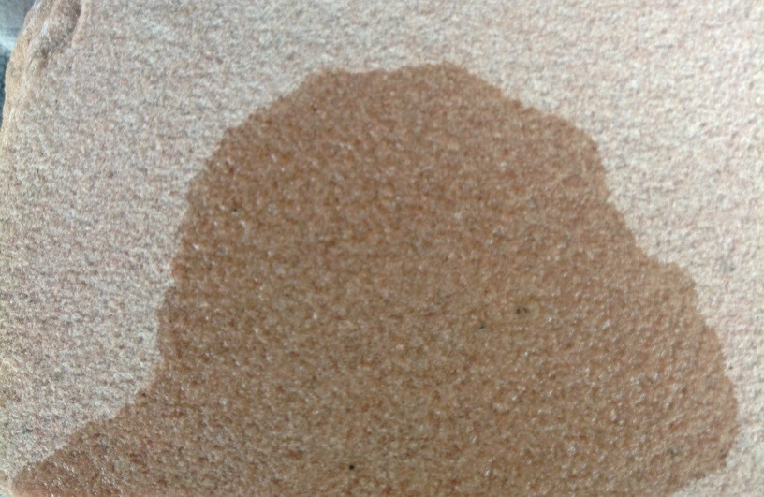
In the previous lab you observed that certain kinds of rocks have open spaces in them called pores. Even though these pores are often microscopic, they still allow fluids to soak in (See photograph to the right). A measure of volume of the pores is called porosity. In this lab you will investigate how the volume of the pores, or porosity, controls the volume of liquid that a material can store.

Materials
- 2-500 ml beakers
- 1-100 ml graduated cylinder
- Aquarium gravel (small gravel)
- Medium sized gravel (available from craft stores)
- Water

Procedure
- Fill one of the beakers with 200 ml of small gravel.
- Fill the other beaker with 200 ml of the medium sized gravel.
- Fill the graduated cylinder with 100 ml of water.
- Slowly pour the water into the small gravel until it reaches the top of the gravel.
- Record in the results section how much water you poured into the beaker.
- Refill the graduated cylinder to 100 ml.
- Slowly pour the water into the medium gravel until it reaches the top of the gravel.
- Record in the results section how much water you poured into the beaker.

Results

Material | Volume  Of  Water Poured | Volume  Of  Gravel | Porosity  In  Percent
Small Gravel |  | 200 ml
Medium Gravel |  | 200 ml

Now you will calculate the porosity of each type of gravel using the following formula:

Porosity = (Volume of Water Poured ÷ Volume of Gravel) X 100

Analysis and Conclusions
- Which size gravel has the greatest porosity?

- If you had a beaker of sand, would it have more or less porosity than the gravel?

- Why is porosity important for the formation of oil and natural gas deposits?

