Student Handout 1
Name ____________________
Date _____________________
Class _____________________

Lesson 3—Oil and Natural Gas Exploration and Production
Lab 1—Understanding Density

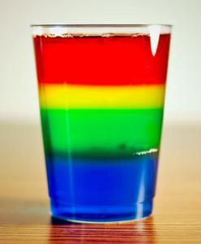
Introduction
If you throw a piece of wood into a lake what does it do? Why? In this lab you will be introduced to the concept of density and how it influences the interaction between substances. Density can be simply defined as a measure of how close together the atoms are in a substance and is a physical property of all matter. Density differences between rock, water, oil, and natural gas are a major control over the movement of these materials in the Earth’s crust and are an important factor in creating oil and natural gas deposits.
Look at the picture on the right. How can these different colored liquids exist as separate layers? That is what you will investigate in this lab.

Materials
- Glass jar with lid or empty water bottle with lid
- 2-3 oz. plastic cups
- Vegetable oil
- Water

Procedure
- Use one of the plastic cups and pour 6 oz. of vegetable oil into the jar.
- Use the other plastic cup and pour 6 oz. of water into the jar.
- Observe what happens to the water.
- Make a drawing of the contents in the jar in the results section.
- Put the lid securely on the jar and shake it for about 10 seconds.
- Place the jar on the desk in front of you and observe what happens to the liquids.
- After it sits for a minute, make another drawing of the contents in the jar.

Results
Make two drawings of the jar and label the layers.

After Shaking
Before Shaking

Analysis and Conclusions
- What was in the jar before you poured in the liquids?

- What happened to the oil when you poured in the water? Why?

- How many layers are in the jar?

- What happened to the liquids in the jar when you shook it and allowed it to sit? Why?

- There is an expression that states “Oil and water don’t mix.” Is this true? Why?

