Oil and Natural Gas in Arkansas—Fossil Fuel Resources from the Natural State
Student Handout 4
Name ____________________
Date _____________________
Class _____________________

Lesson 1—Oil and Natural Gas and How They Form
Lab 2—Organic Matter and Natural Gas

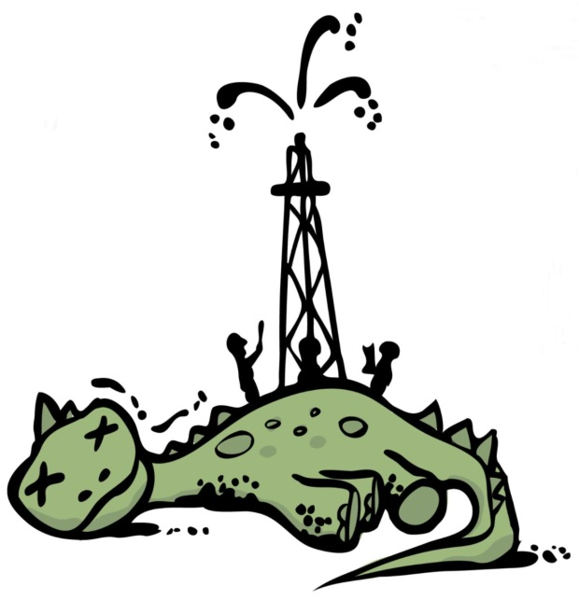
Introduction
In this lab students will observe the connection between the decay of organic material to the formation of natural gas.

Materials
- 2 plastic water bottles
- Organic substance (tuna, ground beef, or egg)
- Lettuce
- Sand
- Balloon
- Water
- Masking tape
- Balance scale

Procedure
- Measure 10g of an organic substance (tuna, beef, or egg) and put into bottle.
- Tear the lettuce leaves into small pieces and put into bottle.
- Use the balance scale to measure 50g sand. Carefully pour the sand into the bottle so that it covers the organic substance and lettuce. Do not shake the bottle.
- Measure 10ml of water. Slowly pour the water into the bottle. Try to make it run down the inside of the bottle instead of pouring it directly onto the sand.
- Stretch the opening of the balloon over the opening of the bottle. Seal with masking tape.
- Prepare a second bottle without the organics material. This will be a control bottle.
- Put both bottles in a warm place (preferably outside as contents could produce a strong odor).

- Over the next several days you will be making observations of both bottles describing changes to the balloon and the material in the bottles.

Results

Day | Bottle with Organic Material |  | Control Bottle
 | Describe Changes to the Balloon | Describe Changes to the Material | Describe Changes to the Balloon | Describe Changes to the Material
1
2
3
4
5
6
7
8
9
10

Analysis and Conclusions
- What is causing the balloon to expand?

- Is there a difference in the balloons between the two bottles? Why?

- Based on the observations of both bottles, what can you conclude about the origin of the gas that filled the balloon?

