Oil and Natural Gas in Arkansas—Fossil Fuel Resources from the Natural State
Student Handout 3
Name ____________________
Date _____________________
Class _____________________

Lesson 1—Oil and Natural Gas and How They Form
Lab 1—What are Fossils?
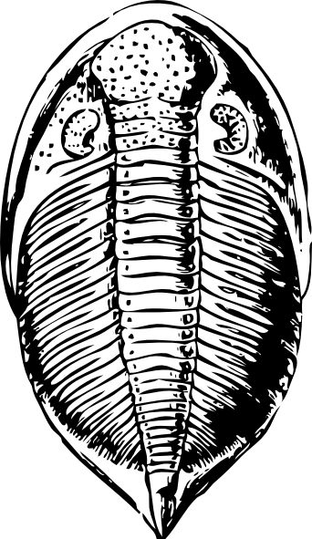
Introduction
In the previous activities you learned that oil and natural gas are known as fossil fuels. You will now investigate the concept of a “fossil” in more detail. A fossil is the remains of a once living organism. Fossils come in two basic types: body and trace. Body fossils are the organism itself, some part, or an impression of it. Trace fossils are evidence of an organism’s presence like a footprint or trail. In this lab you will observe the characteristics of different kinds of plant and animal fossils.

Materials
- Bag or box of 8 fossil specimens*
- Magnifying glass
- Fossil book(s)

(*Fossil specimens can be obtained through educational supply houses like Wards Natural Science, personal collections can also be made of local fossils by consulting the Arkansas Geological Survey publication Fossils of Arkansas by Tom Freeman.)

Procedure
- Remove the fossil specimens and lay them out on your desk.
- Use your senses to carefully observe each specimen, use the hand lens if necessary.
- Make a detailed drawing of each fossil.
- Based on your observations, you will hypothesize whether each fossil is a body part or a trace of an organism. Record your hypothesis in the data table.
- Now use your observations to hypothesize if each fossil represents a plant or an animal. Record your hypothesis in the data table.
- Use the fossil book(s) to identify each fossil.
- Use the fossil book(s) to determine if your hypotheses were correct and record the answers in the data table.

Actual | Is the Fossil a Plant or Animal?
 | Is the Fossil a Body or Trace Fossil?
Identification
Hypotheses | Is the Fossil a Plant or Animal?
 | Is the Fossil a Body or Trace Fossil?
Drawing

Actual | Is the Fossil a Plant or Animal?
 | Is the Fossil a Body or Trace Fossil?
Identification
Hypotheses | Is the Fossil a Plant or Animal?
 | Is the Fossil a Body or Trace Fossil?
Drawing

Analysis and Conclusions

- Which fossils give a more complete image of the entire organism?

- What characteristic of the animal fossils allowed them to be preserved?

- What do you think was necessary for the plant fossils to be preserved?

- Which of the animal fossils are invertebrates? Vertebrates?

- What conclusions can you reach about the environment that each of the organisms lived in?

References

Freeman, Tom. Fossils of Arkansas. Little Rock, Arkansas: Arkansas Geological Commission, 1989.

Potts, Joanna, ed. Guide to Fossils. Buffalo, New York: Firefly Books, 2003.

Rhodes, Frank H.T., Zim, Herbert S., Shaffer, and Paul R. Fossils: A Guide to Prehistoric Life. A Golden Nature Guide. New York, New York: Golden Press, 1962.

Thompson, Ida. National Audubon Society Field Guide to North American Fossils. New York, New York: Alfred A. Knopf, 1995.

Walker, Cyril and Ward, David. Fossils. Smithsonian Handbooks. New York, New York: Dorling Kindersley, 2002.

