Student Handout 4
History of Arkansas’ Oil and Natural Gas Industry
Find Your Place

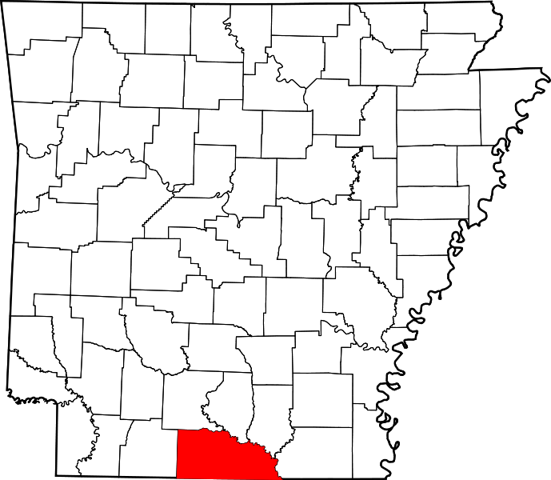

El Dorado and Smackover are in Union County, Arkansas.

Assignment #4 – Put a dot on the map for the city in which you live. Then draw a line from your city to Union County. Using an Arkansas Highway map, determine approximately how far it is between your hometown and Union County?

